aggregation impact on the filtration and growth rates of mussels Mytilus galloprovincialis LAM.

Elena Vasechkina, Marine Hydrophysical Institute RAS, vasechkina.elena@gmail.com
Irina Kazankova, Institute of Natural and Technical Systems RAS, ikazani@ua.fm

Abstract. This study presents the results of field and laboratory-based experiments performed to determine the mussel density effect on an individual mollusk’s growth and clearance rates. We measured the weight and length growth rates of single and aggregated mussels exposed into the sea for three monthly periods in summer and autumn 2015. The sample group contained 140 mollusks from natural populations within the length range of 15-20 mm. The average growth rate of aggregated mussels was almost the same as the growth rate of single ones. Clearance rate of single and aggregated mussels was measured in the laboratory using indirect method. There were selected 5 groups of mussels within the length ranges: 12-16 mm, 17-18 mm, 18-25 mm, 22-23 mm, and 35-38 mm. The clearance rate was measured for each mussel from the group and then for the whole group aggregated in a clump. Water temperature and seston concentration were the same for single and clumped mollusks. The volume of water in chambers was proportional to the weight of mussels put in water. The ratio of aggregated and single mussels’ clearance rates varied from 0.48 to 0.85 at the same density of aggregation and without regard to the animal size. Significant individual variability was recorded in all field and laboratory-based experiments.

Key words: mariculture, Bivalvia, growth in aggregation, clearance rate, laboratory-based experiments

I. Introduction
FAO estimates that the world production of aquaculture increases almost twice every 10 years. Sustained development of aquaculture depends on effective minimizing of the mariculture harmful effect on the environment. Most of scientists agree that problem can be solved by passing from monocultures to integrated polyculture that means simultaneous cultivation of several species with different trophic level like fish, macrophytes, filter-feeders and detritophags. Cultivated species should be chosen to make excretory products of one species consumed by other species.
With the right choice of integrated polyculture components, their disposition and total weight according to the ecological capacity of the district, system comes to a balance thus minimizing any environmental impact. In fact the artificial ecosystem is created inside the natural one and it functions without making any harm. Practical biotechnology development must be preceded by creating information technology including the simulation model and the system collecting and processing information about the real system functioning [1]. Earlier we developed such simulation model including the description of the cultured mollusks and macroalgae, hydrochemical unit and comparatively simple hydrodynamic model [2, 3]. This paper reveals only one component of this model such as the unit reproducing the growth of mussel Mytilis galloprovincialis on artificial substrate [4]. Empirical relations used in this unit were obtained in the laboratory-based conditions and need to be verified to imitate the cultivated species functioning within natural environment. Dense clumps of mollusks are formed on collectors of marine mussel plantations. There are reasons to suppose that physiological functions of specimen in such aggregations differ from physiological functions of specimen in laboratory. In this connection, to have these functions described adequately in the model we have to assess the influence of aggregation and adjust the empirical relations obtained in the laboratory for isolated mussels.
Studies on physiological characteristics changes of bivalves in clumps are very limited. The process of clump-forming itself is not studied well yet. Number of researchers supposes this process to be of random nature. Their opponents claim the forming of clumps to be the result of active behavior responses of mollusks [5]. We can assume that aggregative changes in physiological processes are one of the most important reasons of aggregation forming. One of the earliest studies of aggregation impact on mollusks’ oxygen consumption rate was the research [6]. The laboratory-based experiments conducted in [6] revealed that specific oxygen consumption rate diminishes in relation to the number of mollusks in one chamber. Similar study was made in [7]. Researchers held experiments in the laboratory with the fresh-water bivalve mollusk Elliptio complanata and came to the same conclusion.
Density impact on the effective clearance rate of the bivalves was studied in [8, 9]. The authors of [8] fixed that the average effective clearance rate for isolated individuals was higher than that for those in clumps. They explain decrease of the clearance rate in dense aggregations by increased refiltration in the cores of the clumps. The results of [9] showed the significant effects of mussel density and the seston concentration on the effective clearance rate of mussels. As opposed to [8], the higher clearance rates in experiments were obtained at denser mussel clumps. The authors suppose that obtained results were connected with the high concentration of food particles used in the experiments. They hypothesized that refiltration could have an opposite effect and reduced negatively high food concentrations down to a more favorable range for less exposed mussels. But some other experiments should be carried out to check this hypothesis. Authors of [Tuchman] measured the ingestion rate in dense colonies of bivalves and came to conclusion that ingestion of mussels located within middle and bottom layers of the colony was less due to the suffering from reduced access to food resources. There were no information about ingestion or filtration abilities of a colony as a whole compared to the isolated mussels.
We failed to find another papers concerning aggregation impact on filtration and growth rates of mussels in the literature that is why we had held mussels’ growth monitoring on collectors at the nearshore zone and laboratory-based study of density influence on mussels’ filtration rate. The results of our work are described below.

II. Aggregation impact on the growth rate of mussels
Natural experiment was carried out in Martynova Bay, Sevastopol to study the aggregation impact on mussels’ growth rate. We chose 140 mollusks from natural populations within the length range 15-20 mm. Length, width and wet weight of mollusks were measured, and then samples were divided into 7 groups by 20 specimens. Two groups were used for measuring the growth rate of mollusks growing separately to be referred to as “isolated” mussels hereinafter. Other groups were meant to evaluate the mussels’ growth rate in clumps. While exposing at sea, isolated mussels were arranged in cages by two specimens in each. Other groups of mussels were placed in cotton mesh bags where mollusks formed clumps of approximately the same density. All groups were exposed in the sea coastal zone on experimental collectors for the period from June till November.
Averages, standard deviations and coefficients of variation were calculated upon the results of monthly measurements of mussels’ linear and weight growth. Average growth rates of isolated mussels and those in clumps had been compared. During the first monthly period (from June, 12 to July, 13) we used plastic cages but they malformed the shells of mussels and curbed the linear growth of mollusks so the results of that period had to be rejected.
Diagrams on Fig. 1 show average linear growth rates for different periods of time. Linear growth rate of mussel was counted according to the formula:

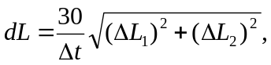 (1)

where L₁ and L₂ – length and height of mollusk’s shell, Δt – time when collectors were exposed in the sea.
Specific weight rate was calculated upon the wet weight measurements:

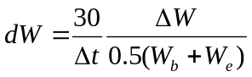, (2)

where W_{b} and W_{e} – original and terminal measurement of specimen’s wet weight.
Diagrams on Fig. 2 demonstrate specific weight rates for different periods of time in comparison.

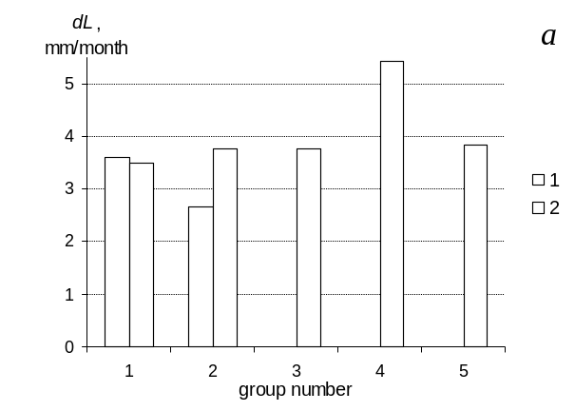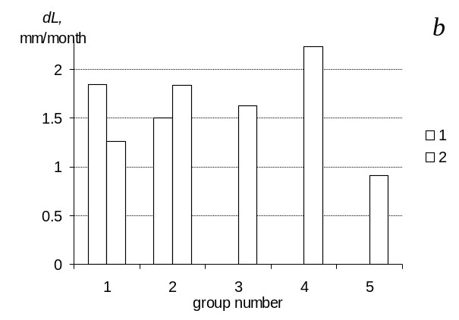
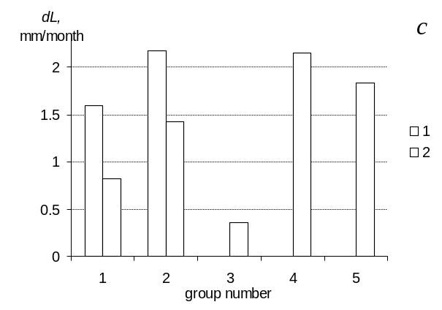
Fig.1. Average linear growth rates (dL) in groups of isolated mussels – 1 and mussels in clumps – 2 during the time periods: a – July-August; b – August-September; с – September-November.

Diagrams on figs. 1 and 2 are qualitatively similar that proves sufficient accuracy of measuring mollusks’ wet weight (mollusks were scaled with the water inside their shells). Great intergroup variation of rates draws our attention because it means that individual living characteristics of mollusks vary greatly as conditions of mussel groups on collectors and their food supply were almost the same.
It was supposed that isolated mussels would grow faster as they are provided with oxygen and food better and do not compete with their neighbors for resources. However, comparison of average growth rates of isolated mussels and mussels in clumps didn’t give expected results.

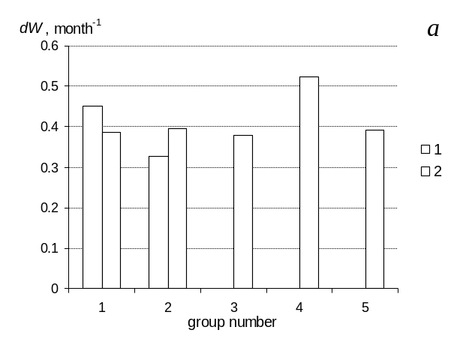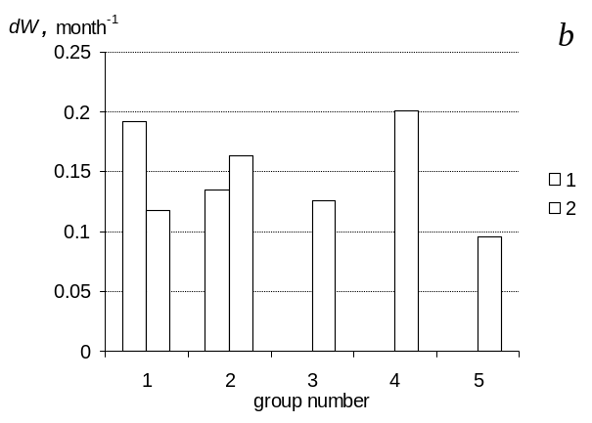
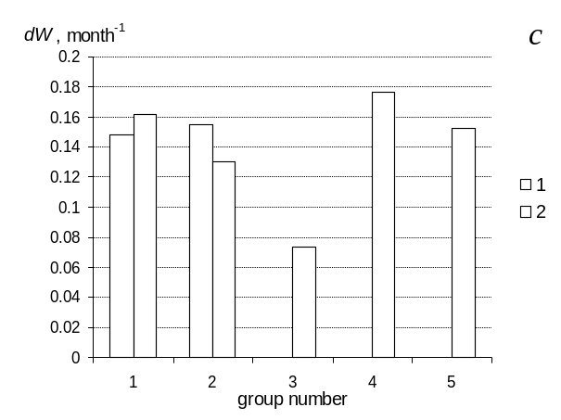
Fig.2. Average specific weight rate (dW) in groups of isolated mussels – 1 and mussels in clumps - 2 during the time periods: a – July-August; b – August-September; с – September-November.

Fig. 3 demonstrates linear and weight growth rates averaged for all groups and for the whole time of experiment in comparison. In the first period of the experiment linear growth rate of isolated mussels was even smaller than for aggregated mussels. Average specific weight rates of mussels almost match not depending if mussels are isolated or aggregated. The relation between isolated mussels and mussels in clumps is 0.98 for linear growth and 0.95 for specific weight growth rate.

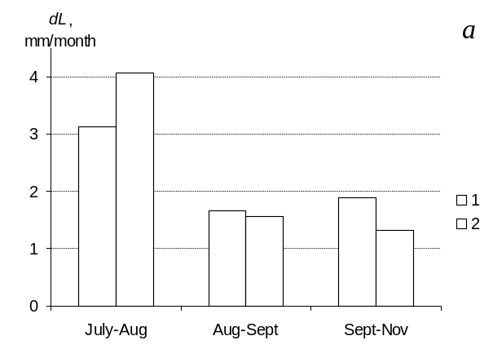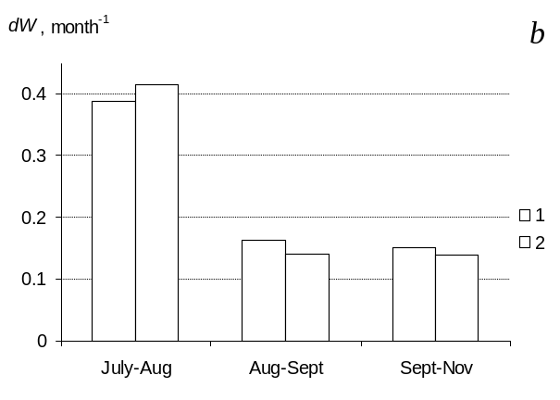
Fig.3. Average linear growth rate (dL) of mussels – a and average specific weight rate (dW) – b for the whole time of experiment. Growth rate of isolated mussels – 1, mussels in clumps – 2.
The mortality coefficient of mussels m (month⁻¹) was also under control. Fig. 4 shows the average meaning in groups of this coefficient.

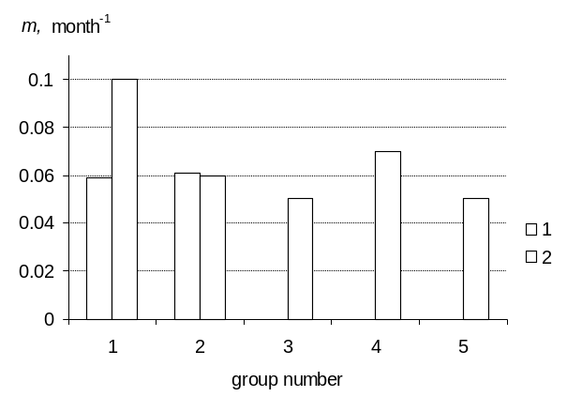
Fig. 4. Average mortality coefficient (m) calculated for the whole period of sea exposition for groups of isolated mussels – 1, in clumps – 2.

The relation between average mortality coefficients of isolated mussels and mussels in aggregation is 1.10 (aggregated mussels – 0.066, isolated – 0.060). Considering high individual variation and limited sample we can accept a hypothesis that disposition of mussels in clumps doesn’t augment the mortality coefficient under otherwise equal conditions.

III. Laboratory study of density influence on mussels’ filtration rate
The filtration rate was estimated by the clearance rate defined as the amount of water cleared from food particles per unit of time. Microalgae Tetraselmis viridis was used to prepare food suspension for experimental mollusks. Optical density with the wave length 750 nm was used as indirect indicator of microalgae biomass. Measurements were held with photoelectric colorimeter PC-3 and a 10 cm cuvette. Transition from optical-density units to absolute dry weight of biomass D was pursued by means of empirical coefficient equal to 0.0375 g∙l⁻¹∙unit of optical density⁻¹ [11].
Five samples of mollusks with similar length parameters were selected from natural populations. The size ranges within groups were: 12 – 16 mm (12 spc.), 17-18 mm (15 spc.), 22-23 mm (15 spc.), 18-25 mm (22 spc.), and 35-38 mm (10 spc.). Each group was used in experiments in two replications to define the filtration rate of mussels separately and in clumps. The studied mussels were placed by one in chambers of equal volumes with sea-water containing food particles. Exposition lasted one hour. Optical density of sea water was measured before and after the exposition. The change of optical density was used to calculate the clearance rate of every mollusk. After the experiment mussels were placed in cotton mesh bags and hung in a container with filtrated sea water for one day. During this time mussels clung to each other forming a clump. Next day that clump was placed in the experimental chamber with food suspension of the same optical density. Water volume was more than in experiments with isolated mussels in proportion to the weight of mussels in the clump. So, the initial phytoplankton density D₀ and the relation V/W were the same as in a previous experiment with isolated mussels, where V – water volume, and W – wet weight of mussels in a chamber. Exposition also lasted one hour with following measuring of water optical density and filtration rate calculation. Water temperature in the experiment varied in a range 23 – 26°С, initial concentration of phytoplankton was 15.6 – 17 mg∙ l⁻¹.
To derive the filtration rate formula C (l∙h⁻¹) we use the equation describing decrease of seston concentration in a chamber of volume V(l) containing n mussels [12]:
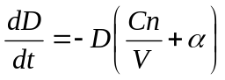, (3)

where D – seston concentration in an experimental chamber, α is the rate at which particles settle out from suspension. The general solution of (3) can be written as

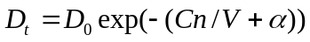, (4)

and
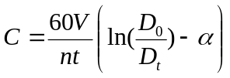, (5)

where D₀ and D_{t} – initial and final seston concentration (g∙l⁻¹), t – time of exposition in minutes.
The rate α can be estimated by the control experiment on measuring changes of seston concentration in a chamber without mussels D':

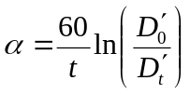. (6)

Our experiment showed this rate to be close to zero so we used the following formula to calculate the average specifiс filtration rate in clumps (l g⁻¹∙h⁻¹):

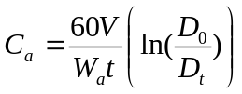, (7)

where W_{а} – wet weight of mussels placed in the chamber (g). Specifiс filtration rate of isolated mussels (l g⁻¹∙h⁻¹) was calculated according to the formula:

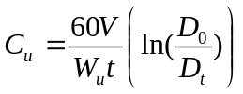. (8)

Fig. 5 demonstrates average filtration rates of isolated mussels and the same mussels joined in clumps in comparison. The relation of aggregated mussels’ filtration rate to the average filtration rate of isolated mussels turned out to be less than 1 and varied from 0.48 to 0.85. Apparently variability of this parameter was influenced by the water temperature and high individual variation of physical characteristics of mussels.
Laboratory experiments let us suppose that filtration rate of aggregated mussels is 15-50% lower than filtration rate of isolated mussels. At the same time we didn’t observe substantial decrease of the growth rate of mussels in clumps. According to the energy balance equation of living organisms, productive energy could be estimated as P = A – R – E (cal∙day⁻¹), with А – assimilated energy, R – metabolic costs, Е – excretion energy. The assimilated energy is proportioned to the consumption I =СK_{d}D, with C – filtration rate, D – concentration and K_{d} – calorific value of food suspension. In this case we can write down P = A_{e}CK_{d}D – R – E with А_{е} – assimilation coefficient.
One can write

(R + E)_{a} < (R + E)_{u} (9)

keeping in mind that productive energy of isolated and aggregated mussels seems to be almost equal (as it was showed by our investigation of growth rate of mussels on collectors), initial concentrations of suspension were equal, assimilation coefficients were the same (as experiment was held with the same mussels), and filtration rate of aggregated mussels was lower than that of isolated mussels.
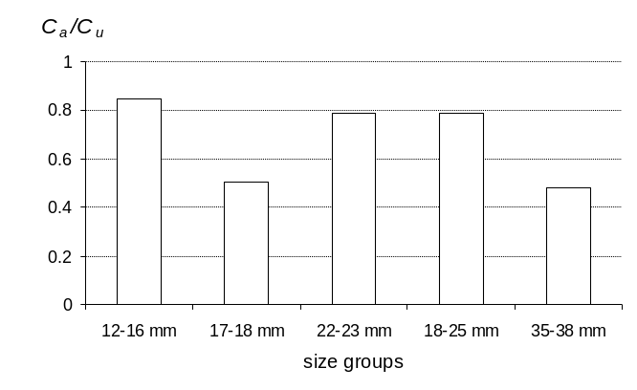
Fig. 5. Relations obtained in the experiment between aggregated mussels filtration rates and the filtration rate of isolated mussels (C_{а}/С_{u} ) averaged for all the groups.

Excretion energy (E) is still under-explored. According to [13], excretion depends on mollusk’s weight and concentration of food particles in water. Excretion energy is smaller by an order of magnitude than metabolic costs, therefore with sufficient precision the relation (9) can be rewritten as R_{a} < R_{u}. That conclusion agrees with previously performed studies. Influence of mussels’ stocking density in a respirometer on the oxygen consumption rate was studied in [6]. At first experimental mollusks were placed in separate respirometers and then they were replaced into one big respirometer with parallel measuring of oxygen consumption. Water volume per one specimen was 312 ml for mussels in aggregations and 250 ml for isolated mussels. Fig. 6 demonstrates the results of that experiment. 80% of measurements revealed the relation R_{а}/R_{u} to be less than 1, average obtained meaning was 0.92. Experiments when aggregated mussels had half as much water volume as isolated ones showed that oxygen consumption rate of the first was sufficiently lower than that of the second. In that case average ratio R_{а}/R_{u} decreased to 0.77 [6].

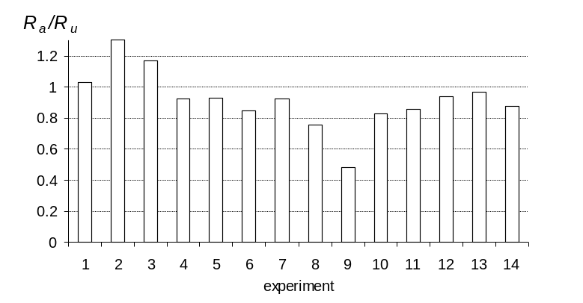
Fig. 6. The ratio of oxygen consumption rates of aggregated and isolated mussels (R_{а}/R_{u}) based on data presented in[6]. Water temperature 22 – 23 °С.

Dependence of hydrobionts’ specific basic metabolic costs on patch density is known for many kinds of aquatic organisms (physiological activities decrease in aggregations). In the case of mussels clumps, this can be explained by the limited (comparing to the isolated mussels) life space available for a mussel in a clump to take necessary nutrients and energy from the ambient water. It’s reasonable to assume that mollusks from biofouling cenosis would experience this effect much bigger as they form very dense aggregations. Physical activity of mussels in aggregation decreases much more under the low current velocity because of metabolic products accumulation and oxygen depletion as the result of mussels’ oxygen consumption. This phenomenon must be taken into account in the simulations of mussels’ functioning on collectors of a mussel farm. It should be considered for accurate description of matter interchange between the artificial and natural ecosystems and estimation of ecological capacity of marine area planned for mariculture. To develop reliable empirical relations some additional laboratory-based experiments are needed to calculate the filtration rate and the oxygen consumption rate of mollusks under the variable environmental conditions, such as temperature, concentration of feeding suspension and the density of clumps.

V. References
[1] E. F. Vasechkina, “Concept of informational technology of sustainable development support of mariculture in the nearshore zone of Crimea”, Environmental control systems, 2014, vol. 20, pp. 220-225.
[2] E. F. Vasechkina, “Multi-element model of the pelagic plankton community”, Environmental control systems, 2013, vol. 19, pp. 247-252.
[3] E. F. Vasechkina, “Simulation of an integrated multi-trophic aquaculture”, Proc. of Conf. MARESEDU – 2015, Moscow, MSU, October 2015, pp. 463-466.
[4] E. F. Vasechkina, I. I. Kazankova, “Mathematical modeling of the growth and development of the mussel Mytilus galloprovincialis on artificial substrates”, Oceanology, 2014, vol. 54, № 6, pp. 763-770.
[5] P. A. Lezin, “Peculiarities of aggregative behavior and spatial organization of mussels Mytilus edulis in the White Sea”, PhD thesis in biology, Institute of Zoology RAS, S.-Petersburg, 2009.
[6] V. D. Brajko, “Dependence of mussels’ breathing on the size of respirometers”, Biologiya morya, 1979, vol. 48, pp. 15-21.
[7] C. G. Paterson, “Effect of aggregation on the respiration rate of the freshwater unionid bivalve Elliptio complanata (Solander)”, Freshwat. Inv. Biol., 1983, № 2, pp. 139-146.
[8] N. Yu, D. A. Culver, “Estimating the effective clearance rate and refiltration by zebra mussels, Dreissena polymorpha, in a stratified reservoir”, Freshwater Biology, 1999, vol. 41, pp. 481-492.
[9] A. Zaiko, D. Daunys, “Density effects on the clearance rate of the zebra mussel Dreissena polymorpha: Flume study results”, Hydrobiologia, 2012, vol. 680, pp. 79–89.
[10] N. C. Tuchman, R. L. Burks, C. A. Call, J. Smarrelli, “Flow rate and vertical position influence ingestion rates of colonial zebra mussels (Dreissena polymorpha)”, Freshwater Biology, 2004, vol. 49, pp.191–198.
[11] A. B. Borovkov, R. G. Gevorgiz, “Productivity of Spirulina platensis and Tetraselmis viridis under various methods of cultivation”, Ecologiya morya, 2005, vol. 70, pp. 9-13.
[12] J. Coughlan, “The estimation of filtering rate from the clearance of suspensions”, Mar. Bio., 1969, № 2, pp. 356-358.
[13] V. I. Kholodov, A. V. Pirkova, L. V. Ladygina, “Functional characteristics of a typical mussel farm”, Rybnoye khozyajstvo Ukrainy, 2011, № 5, pp. 48-55.

